Enterprise level topics
- A NAT Gateway (Network Address Translation Gateway) is a networking service that allows private resources (such as VMs in a private subnet) can reach outbound internet access, while preventing inbound access
Example: When VM has the private IP address associated with, in order to have outbound internet access it should have NAT gatway.
- A NIC (Network Interface Card) is a virtual network adapter attached to a VM. It connects the VM to a subnet within a VNet, provides the VM with a private IP address, and can optionally be associated with a public IP
- A Network Security Group (NSG) is a virtual firewall that controls inbound and outbound network traffic by allowing or denying traffic based on rules. An NSG can be associated with either a subnet or a network interface (NIC).
- git fetch downloads the latest changes from the remote repository but does not modify your local branch.
- Git pull downloads the latest changes from the remote repository and modify your local branch which may result in merge conflicts if both local and remote have modified the same code."
- git branch: 'feature', url: 'https://github.com/Varcoder-123/Java-3-tier-Application.git'
- in the first build it does git clone
- Later builds fetch, checkout & pull
- The mvn clean compile command first removes any previous build artifacts by deleting the target directory. It then compiles all the Java source files into bytecode (.class files) and stores them under the target/classes directory. These .class files are the bytecode that the JVM can execute. At this stage, the application is only compiled—it has not yet been packaged into a WAR or JAR file.

- OWASP Dependency-Check is a security tool used to identify known vulnerabilities in the third-party libraries (dependencies) that your application uses.
How to push the image to another VM through ansible
- 1st we need to make sure that peering is done
- 2nd install ansible into the Jenkins VM and try to do ssh to different VM using the above-mentioned process
SSH into your Jenkins VM.
sudo apt update
sudo apt install ansible -y
Verify:
ansible --version
Expected output:
ansible [core 2.x]

- Step 3: Generate SSH Key on Jenkins VM
If you don't already have one:
ssh-keygen -t rsa -b 4096
Press Enter for all prompts.
You'll get:
~/.ssh/id_rsa
~/.ssh/id_rsa.pub
- Step 4: Copy Public Key to Application VM
sometimes you may push the id_rsa.pub key but if you try to connect to vm you will receive this error
/usr/bin/ssh-copy-id: ERROR: @@@@@@@@@@@@@@@@@@@@@@@@@@@@@@@@@@@@@@@@@@@@@@@@@@@@@@@@@@@ ERROR: @ WARNING: REMOTE HOST IDENTIFICATION HAS CHANGED! @ ERROR: @@@@@@@@@@@@@@@@@@@@@@@@@@@@@@@@@@@@@@@@@@@@@@@@@@@@@@@@@@@ ERROR: IT IS POSSIBLE THAT SOMEONE IS DOING SOMETHING NASTY! ERROR: Someone could be eavesdropping on you right now (man-in-the-middle attack)! ERROR: It is also possible that a host key has just been changed. ERROR: The fingerprint for the ED25519 key sent by the remote host is ERROR: SHA256:RJA5ES6X6isrOH8cMzosk4upD9mKw/T1QiDc4PdrHEc. ERROR: Please contact your system administrator. ERROR: Add correct host key in /root/.ssh/known_hosts to get rid of this message. ERROR: Offending ECDSA key in /root/.ssh/known_hosts:3 ERROR: remove with: ERROR: ssh-keygen -f '/root/.ssh/known_hosts' -R '10.1.1.4' ERROR: Host key for 10.1.1.4 has changed and you have requested strict checking. ERROR: Host key verification failed. root@testing:/home/Vicky# ssh-copy-id -i /root/.ssh/id_rsa.pub azureuser@10.1.1.4

ssh-keygen -f "/root/.ssh/known_hosts" -R "10.1.1.4"
Before you run the below code, if the above error occurred than run the above code
ssh-copy-id -i /root/.ssh/id_rsa.pub azureuser@10.1.1.4
chmod 700 ~/.ssh
chmod 600 ~/.ssh/authorized_keys (usually this permission is not need if required you can use it)

- Step 5: Test SSH
From Jenkins VM:
ssh azureuser@10.1.x.x
If it logs in without asking for a password, you're ready.

- Step 2: Create a Directory for Ansible
On the Jenkins VM:
mkdir ~/ansible
cd ~/ansible
You'll have:
ansible/
├── inventory
├── ansible.cfg
└── deploy.yml
- Step 3: Create the Inventory File
Create inventory:
[app]
10.1.1.4 ansible_user=azureuser
Replace 10.1.1.4 with your Application VM's private IP.

- Step 4: Create ansible.cfg
[defaults]
inventory = inventory
host_key_checking = False
Disabling host key checking avoids interactive prompts the first time Ansible connects.

- Step 5: Test Ansible Connectivity
Run:
ansible all -i ansible/inventory -m ping
Expected output:
10.1.1.4 | SUCCESS => {
"changed": false,
"ping": "pong"
}
If you see pong, Ansible is working.

- Step 6: Install Docker Collection
Your playbook will manage Docker containers, so install the Docker collection:
ansible-galaxy collection install community.docker

- Step 7: Create the Deployment Playbook
Create deploy.yml:
---
- name: Deploy Java Application
hosts: app
become: yes
vars:
docker_image: "{{ image_name }}"

tasks:
- name: Pull latest Docker image
community.docker.docker_image:
name: "{{ docker_image }}"
source: pull
- name: Stop existing container
community.docker.docker_container:
name: java-app
state: absent
- name: Start container
community.docker.docker_container:
name: java-app
image: "{{ docker_image }}"
state: started
restart_policy: always
published_ports:
- "8080:8080"

- Step 8: Test the Playbook
Run it manually:
ansible-playbook deploy.yml \
--extra-vars "image_name=vicky1867/vickstudio:25"

- Now when you run the Jenkins pipeline, it use as Jenkins user than you should make sure that keys must be available in Jenkins user
copy the keys from the root to Jenkins as show below
cp /root/.ssh/id_rsa /var/lib/jenkins/.ssh/
cp /root/.ssh/id_rsa.pub /var/lib/jenkins/.ssh/
chown -R jenkins:jenkins /var/lib/jenkins/.ssh

- when you receive the WARNING: REMOTE HOST IDENTIFICATION HAS CHANGED! Error during the Jenkins build than you have to run this command
sudo -u jenkins
ssh-keygen -f /var/lib/jenkins/.ssh/known_hosts -R 10.1.1.4

- now try to install docker into the application VM
by this way we can prevent the following error
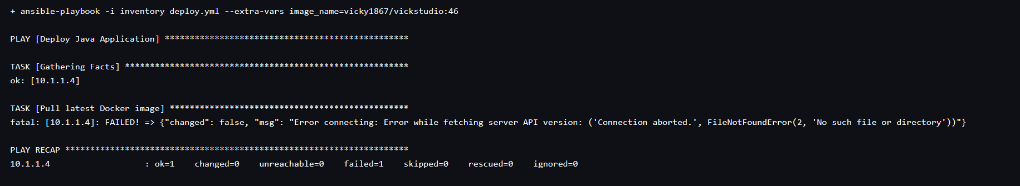

Which region to select for azure Mysql
Make sure you see the compactible region in the azure portal to build the azure MySQL service

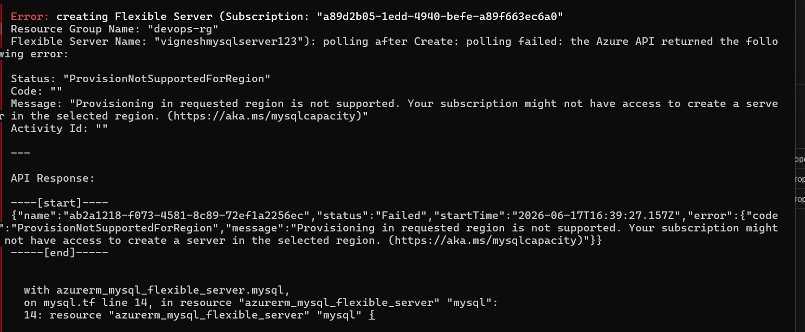

How do you configure OWASP?
- Install the OWASP Dependency-Check Plugin in jenkins
- Add Dependency-Check installations into the tools in jenkins
- Get an NVD API Key https://nvd.nist.gov/developers/request-an-api-key
- Add the API Key to credentials
How to configure SonarQube
- Install SonarQube in Jenkins VM
- Install Sonar scanner plugin in Jenkins
- Configure SonarQube in Jenkins(system)
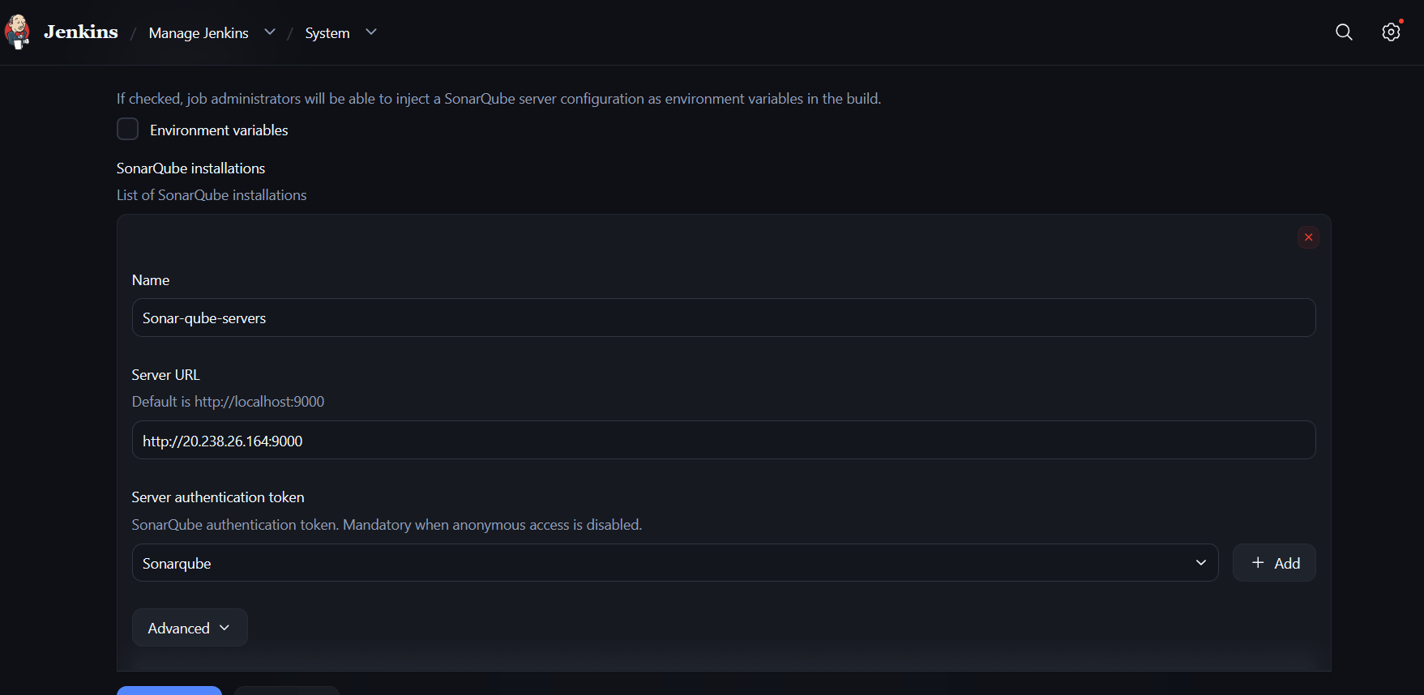
- Generate token in SonarQube and configure this as credentials
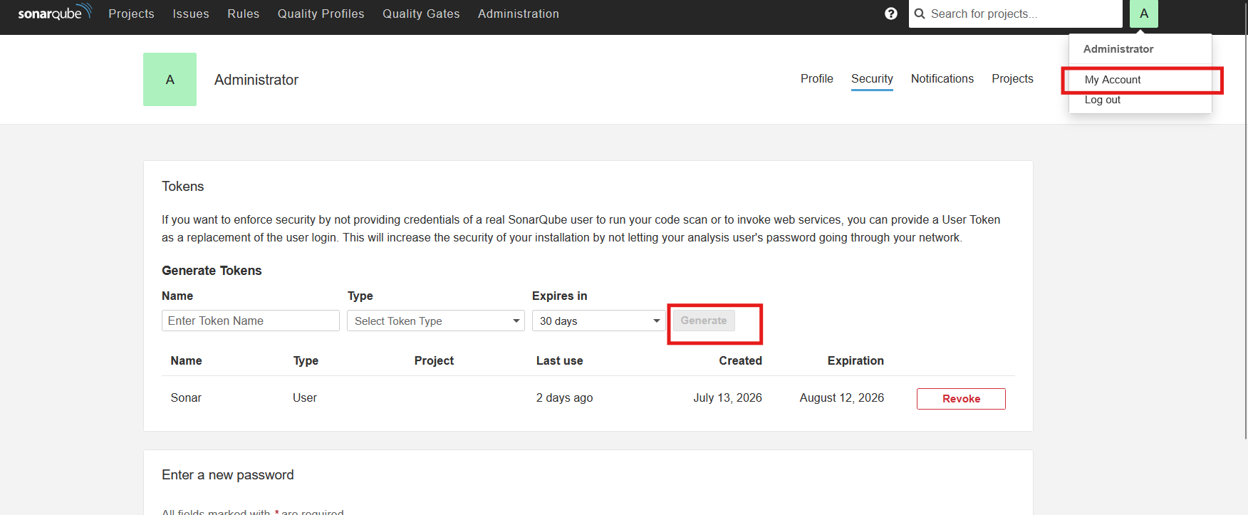
- Install sonar scanner inside tools

How to add quality gate
